Create a Product List application

In this exercise, you’ll create a Product List application that uses a ListView control to display product names and images in Bootstrap thumbnail components.

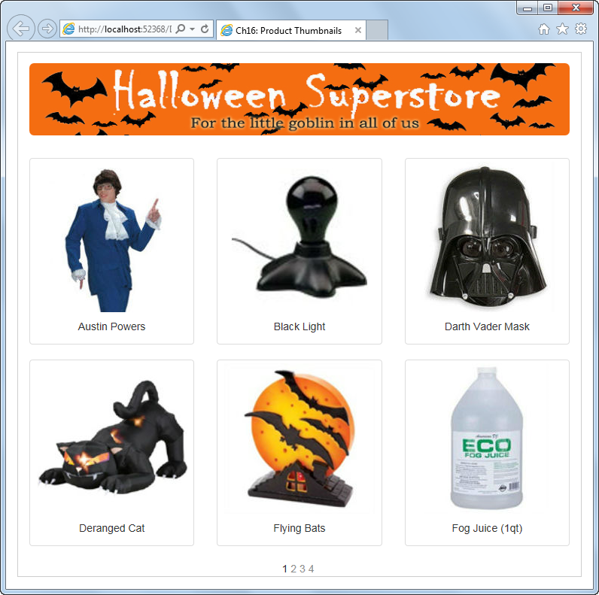

Create and configure the ListView control

1. Open the XEx16ProductList application from the zip file. This application contains the starting page and the database, images, and style sheets used by the page.
2. Add a ListView control to the page, and create a data source that retrieves the Name and ImageFile columns from the Products table, sorted by name.
3. Configure the ListView control so it uses a flow layout. Enable paging and use a Numeric pager.

Edit the Item template and data pager

1. Switch to Source View if you aren’t already there.
2. In the Item template, delete the text that identifies the two fields, as well as all the span elements and line breaks.
3. Replace the label control for the product image in the Item template with an image control. Because the ImageFile column contains just the name of the image file, you will need to add the path to the ImageURL property like this:

ImageURL='<%#"~/Images/Products/" + Eval("ImageFile") %>'

1. Enclose the label control for the product name in a div element, and move that element after the image control.
2. Modify the data pager so only 6 items are displayed at a time and so just the numeric pager is displayed.
3. Delete the templates that aren’t used by this application. Then, run the application to see how it looks.

Improve the formatting with Bootstrap

1. In the Layout template, assign the div tag whose id is itemPlaceholderContainter to the CSS class “row”. Then, assign the div tag that contains the data pager to the CSS class “text-center”.
2. In the Item template, change the default span tag to a div tag and then assign it to the CSS class “col-sm-4”. Then, add a second div tag inside the first one and assign it to the “thumbnail” CSS class.
3. Move the image control and the div tag that contains the label control inside the div tag you added in step 11. Then, assign the div tag that contains the label to the “caption text-center” CSS classes.
4. Run the application to see how it looks. Narrow and widen the browser to see how the images behave.